Lung Ultrasound versus Chest X-ray for Diagnosing Pulmonary Disorders in Neonatal Age Group
Abstract
Background: Neonatal respiratory distress syndrome (NRDS) is a leading contributor to neonatal morbidity and mortality, particularly in neonatal intensive care units (NICUs). Historically, diagnosis relied on clinical assessment, arterial blood gas parameters, and chest X-ray (CXR). However, repeated CXR exposure introduces neonates—especially preterm infants—to ionizing radiation, linked to long-term outcomes, including elevated cancer risk. In this context, lung ultrasound (LUS) has emerged as a compelling alternative, offering several advantages: it is free of radiation hazards, enables bedside application, is repeatable, and user-friendly.
Objective: This review critically examines the comparative utility of lung ultrasound versus chest X-ray in evaluating pulmonary pathologies among neonates, with emphasis on determining the superior modality in clinical practice.
Conclusions: Lung ultrasound warrants integration as an adjunctive technique alongside chest X-ray within diagnostic protocols for neonatal respiratory distress syndrome. Its introduction into routine practice offers a non-ionizing imaging approach that may reduce the frequency of radiographic studies, thereby mitigating radiation exposure in this vulnerable population. Furthermore, from an economic standpoint, LUS is a cost-efficient alternative, as it avoids the need for expensive radiographic infrastructure and consumables. The average expenditure per ultrasound is lower than the cumulative costs associated with serial chest X-rays, underscoring its value in NICU settings with high imaging demands. Ultrasound’s diagnostic precision, ease of access, and absence of contraindications render it invaluable, especially given the emphasis on minimizing radiation risks in neonatology.
Keywords: LUS; CXR; Pulmonary Disorders; Neonatal.

Introduction
The neonatal period marks the most profound physiological transition in human life. While the respiratory and cardiovascular systems undergo abrupt functional shifts at birth, other organ systems adapt more gradually, culminating in the full conversion from intrauterine to extrauterine physiology. This transitional window is pivotal, particularly due to the abrupt cessation of placental support for gas exchange, circulation, and metabolic clearance, necessitating immediate and coordinated neonatal adaptation (De Luca, 2021).
Respiratory pathologies in neonates may stem from delayed postnatal adaptation, structural or congenital anomalies, or acquired insults such as perinatal infections. These conditions represent the leading cause of NICU admissions among both term and preterm newborns (Yang et al., 2024).
Among the most frequently encountered disorders are respiratory distress syndrome (RDS), pneumothorax, pneumonia, pulmonary hemorrhage, aspiration syndromes, pleural effusion, transient tachypnea of the newborn, meconium aspiration, persistent pulmonary hypertension (primary or secondary), congenital pulmonary airway malformation, congenital diaphragmatic hernia, tracheoesophageal fistula, choanal atresia, pulmonary sequestration, and congenital lobar emphysema (Yan et al., 2020)
Given its diverse etiologies, neonatal pulmonary disease remains a predominant cause of respiratory compromise. Escalation into respiratory failure is a major contributor to neonatal mortality globally. Therefore, heightened clinical vigilance and early therapeutic intervention by neonatologists are vital (Wang and Wheeler, 2022).
Chest X-ray (CXR), despite its widespread availability and relatively low radiation exposure, continues to be the frontline imaging modality for evaluating neonatal pulmonary and cardiovascular systems. However, lung ultrasound (LUS) has demonstrated superior diagnostic precision and consistency in detecting conditions such as neonatal pneumonia and other lung pathologies, surpassing CXR in several clinical contexts (Jain et al., 2020).
The utility of ultrasonography (USG) in emergency and intensive care settings has earned it the designation of a “third eye” for clinicians. LUS employs both anatomical landmarks (e.g., ribs, pleural lines) and ultrasound artifacts such as B-lines—distinct vertical hyperechoic reverberations arising from the pleura. The appearance of diffuse, bilateral B-lines is suggestive of interstitial syndromes including pulmonary edema, diffuse parenchymal disease, and interstitial pneumonia (Demi et al., 2023).
In neonates, LUS permits the differentiation between normally aerated lungs—characterized by a homogeneous hypoechoic pattern with pleural sliding and horizontal A-lines—and the echogenic “white lung” pattern typical of fluid-laden or inflamed pulmonary tissue. Non-invasive ventilation (NIV) is commonly utilized in moderate neonatal respiratory compromise to maintain spontaneous respiration while mitigating the risks associated with mechanical ventilation (Mahmoud et al., 2022).
Nonetheless, the ability to predict NIV failure remains limited. Conventional radiographs often fail to correlate with the clinical grading of RDS. By contrast, the persistence of a “white lung” signature on LUS has shown strong correlation with ongoing respiratory distress in preterm infants (Liu, 2023).
Accordingly, this review investigates the comparative diagnostic value of LUS versus CXR in evaluating pulmonary conditions within the neonatal population, with a focus on identifying the superior modality for routine clinical implementation.
Neonatal Pulmonary Disorders
Neonatal respiratory conditions may arise due to delayed postnatal adaptation, congenital anomalies, or infections acquired around the time of birth. A comparative analysis revealed a prevalence of 2.2% in Italy and 6.7% in India, highlighting regional variability in respiratory morbidity among newborns (Kenner and Boykova, 2021).
These conditions represent the most frequent cause of NICU admissions in both term and preterm neonates. For instance, one study reported that respiratory distress was the primary diagnosis in 33.3% of neonates admitted beyond 28 weeks of gestation, while another identified signs of RD in 20.5% of cases. The global uptick in cesarean deliveries may be partially responsible for the increasing incidence of such admissions (Sharma et al., 2021)
- Respiratory Distress in Neonates
Etiologically, neonatal RD may stem from medical, surgical, congenital, or systemic origins (Bos and Ware, 2022).
- Respiratory distress syndrome
RDS is an acute pulmonary disorder primarily affecting neonates between 26–33 weeks’ gestation, though it may also present in term infants following cesarean section, perinatal hypoxia, or in infants of diabetic mothers. The hallmark of RDS is a surfactant deficiency leading to alveolar collapse and impaired gas exchange (De Luca et al., 2021).
Incidence correlates inversely with gestational age, and preterm neonates remain at the highest risk (Yildiz Atar et al., 2021).
Epidemiology and Risk Factors
Surfactant deficiency is the principal factor predisposing preterm infants to RDS, with additional risk noted among offspring of diabetic mothers (Liu et al., 2021).
Clinical and Radiological Aspects of RDS
Clinically, RD manifests as signs of increased respiratory effort including tachypnea, nasal flaring, subcostal retractions, and expiratory grunting. The normative neonatal respiratory rate ranges from 30–60 breaths/min, with tachypnea defined as a rate exceeding 60 breaths/min (Reuter et al., 2014).
This compensatory response may indicate hypercapnia, hypoxemia, or acidosis, yet remains a non-specific marker found in respiratory, cardiovascular, metabolic, or systemic illnesses (Trinavarat and Riccabona, 2023).
Radiographically, conditions such as diaphragmatic paralysis, CPAM, pneumothorax, mediastinal mass, or CDH may be visualized, as they compromise thoracic compliance and pulmonary inflation. When tachypnea is disproportionate to physical signs of distress, metabolic causes or systemic infections like sepsis should be investigated through laboratory analysis (Grant and Griffin, 2024).
RDS Management
Advancements in the treatment of RDS have markedly transformed neonatal outcomes, particularly following the introduction of exogenous surfactant therapy. Clinical improvements have also been closely tied to the prenatal administration of corticosteroids and the application of positive end-expiratory pressure (PEEP), both of which help maintain alveolar patency and mitigate atelectasis (Perri et al., 2020).
Pulmonary surfactant plays a critical role in stabilizing alveoli by reducing surface tension within the air sacs. In neonates with RDS, surfactant deficiency impairs gas exchange and predisposes to alveolar collapse. The therapeutic efficacy of surfactant extracts in enhancing survival has been well-established. However, the optimal timing for initiation has remained a point of clinical inquiry. A review of randomized trials comparing early selective administration (within the initial two postnatal hours) to delayed intervention demonstrated a clear benefit associated with early delivery, suggesting a time-sensitive therapeutic window (Lindfors et al., 2021).
Chronic Neonatal Lung Disease / Bronchopulmonary Dysplasia (BPD)
Bronchopulmonary dysplasia (BPD) stands as a prevalent and severe complication of prematurity, resulting from interrupted alveolar development in immature lungs subjected to mechanical ventilation, supplemental oxygen, and inflammatory stimuli before pulmonary maturation is complete. Clinically defined by the need for oxygen therapy at 36 weeks’ corrected gestational age, BPD affects approximately 32% of preterm neonates and nearly half of those with very low birth weight (Figure 4) (Giusto et al., 2021).
- Full-term Infant Respiratory Distress
Though commonly associated with prematurity, RDS also occurs in term infants, primarily due to severe perinatal infections or elective cesarean deliveries. The highest risk is observed when delivery occurs before the onset of labor, as the physiologic mechanisms necessary for fetal lung fluid clearance may be underdeveloped (Osman et al., 2023).
Term RDS can be classified into three distinct etiologies:
- ARDS: Triggered by catastrophic insults such as birth asphyxia, sepsis, shock, or coagulopathy.
- IRDS: Often observed in neonates delivered by elective cesarean section, with earlier deliveries correlating with increased incidence.
- Genetic surfactant deficiency: A rare but serious contributor associated with inborn errors of surfactant metabolism (Kim et al., 2022).
- Transient Tachypnoea of the Newborn (TTN)
Transient tachypnoea of the newborn (TTN) is a self-limited respiratory disorder marked by rapid breathing within the initial hours of life, typically resolving within 72 hours without the need for invasive intervention (Bärenson et al., 2024).
The condition is linked to delayed clearance of fetal lung fluid, a process normally regulated by hormonal changes near term and during labor. Catecholamines and glucocorticoids activate sodium transport pathways that drive alveolar fluid reabsorption. Although vaginal birth provides some mechanical assistance, hormonal signaling is the principal mechanism. TTN is reported in approximately 10% of infants born at 33–34 weeks, 5% at 35–36 weeks, and less than 1% among term neonates (Bruschettini et al., 2022).
- Meconium aspiration syndrome (MAS)
Meconium aspiration syndrome (MAS) remains a considerable source of neonatal morbidity and mortality, particularly in resource-limited settings. Historically, aggressive airway suctioning was routinely performed for all infants born through meconium-stained amniotic fluid (MSAF), regardless of their clinical vigor. However, evolving evidence has led to the abandonment of this practice, with guidelines now discouraging routine intubation and suctioning in the absence of respiratory compromise (Gallo et al., 2023).
Clinical and Radiological Aspects of MAS
Diagnostic criteria for MAS typically include: respiratory distress in a neonate delivered through MSAF, oxygen dependency within the first two hours of life that persists for at least 12 hours, oxygen saturation maintained above 92% with supplementation, and exclusion of congenital malformations of the lungs, heart, or airways (Busgeeth, 2022).
Initial CXR often reveals streaky linear opacities that evolve into hyperinflation with patchy infiltrates (Figure 5). Air leaks, such as pneumothorax or pneumomediastinum, are noted in 10–30% of affected neonates. Blood gas analysis commonly shows hypoxemia and hypercapnia, reflecting ventilation-perfusion mismatch (Dini et al., 2024).
- Neonatal pneumonia
Neonatal pneumonia may mimic systemic infection, with presentations including respiratory distress and unstable temperature regulation. Radiological features range from initially normal to patchy consolidations and air bronchograms. In some cases, bilateral granular patterns or diffuse infiltrates with associated effusions—observed in up to 67%—are present (Figure 6) (Kushnareva et al., 2019).
- Surgical causes
Congenital Diaphragmatic Hernia (CDH)
CDH results from diaphragmatic maldevelopment allowing abdominal organs to herniate into the thorax, impeding lung growth and alveolar development. The incidence is approximately 1 in 2500 live births (Zani et al., 2022).
CPAM, formerly CCAM, is characterized by benign overgrowth of terminal bronchioles forming cystic lesions, usually limited to a single lobe. Antenatal ultrasound may detect hyperechoic lung areas, which are more precisely evaluated by fetal MRI. Postnatal imaging often shows cystic lucencies on CXR, but CT provides definitive characterization (Elron et al., 2020)(Wang and Wheeler, 2022).

Congenital lobar overinflation (CLO)
CLO, also referred to as congenital lobar emphysema, typically involves lobar hyperinflation due to bronchial obstruction. The left upper lobe is most frequently affected. Imaging may show overdistention of the affected lobe, adjacent collapse, and mediastinal shift. CT aids in diagnosis and in excluding reversible causes (Demir et al., 2019).
Bronchopulmonary sequestration
Bronchopulmonary sequestration is defined by nonfunctioning pulmonary tissue that lacks tracheobronchial continuity. The extralobar variant often presents in neonates. Radiographic findings may mimic CPAM or infectious processes, and CT angiography is often necessary for differentiation (Shafiq et al., 2021).
Other extrapulmonary causes of distress include anomalies such as tracheoesophageal fistula, tracheomalacia, bronchopulmonary foregut malformations, congenital cardiac defects, and structural thoracic abnormalities (Kumbasar et al., 2024).
- Congenital cardiac causes
Neonatal respiratory compromise may stem from cardiac pathologies, including pulmonary edema secondary to left-sided failure or obstructed venous return. Clinical signs—cyanosis, murmurs, and acidosis—suggest underlying heart disease. Radiologic findings include cardiomegaly, pulmonary congestion, and interstitial edema. While PDA is a common cause in preterm neonates, lesions such as VSD and atrioventricular canal defects are more typical in term infants (Suprenant and Coghlan, 2016).
- Lung Ultrasonography in Neonatal Pulmonary Disorders
LUS has emerged as a valuable, radiation-free diagnostic modality for assessing neonatal lung pathology. Its effectiveness is amplified in neonates due to their small thoracic dimensions and compliant chest wall, allowing for enhanced acoustic penetration. Unlike traditional CXR, LUS offers bedside feasibility, reproducibility, and minimal training requirements, making it an ideal tool in the NICU setting (Singh et al., 2024).
Respiratory distress syndrome
RDS, prevalent among preterm neonates, arises from pulmonary surfactant deficiency and often necessitates surfactant replacement and ventilatory support. Characteristic LUS findings in RDS include lung consolidations, static or dynamic air bronchograms, pleural line thickening or irregularity, and compact B-lines. In more severe cases, the presence of lung pulse and pleural effusion may also be observed (Liu, 2023).
Transient tachypnea of the newborn
LUS offers superior sensitivity and specificity in distinguishing TTN from hyaline membrane disease and neonatal pneumonia. TTN typically presents with bilateral—but frequently asymmetric—distribution, a smooth pleural line, absence of significant subpleural consolidations, and diffuse B-lines reflecting pulmonary edema. While the double lung point (DLP) alone lacks diagnostic specificity, its combination with B-line patterns significantly enhances diagnostic accuracy (Blank et al., 2017).
Clinically, TTN manifests as mild, self-limiting respiratory distress resolving within 24–48 hours, though persistent symptoms may occur in severe cases. Pulmonary fluid retention is the hallmark feature, leading to interstitial and alveolar edema (Alhassen et al., 2021b).
Pneumonia
LUS has emerged as a reliable, non-invasive modality for diagnosing neonatal pneumonia. Hallmark sonographic features include subpleural consolidations with irregular or shredded margins, dynamic air bronchograms, pleural line abnormalities, and occasional pleural effusion. Notably, LUS has demonstrated exceptional diagnostic performance, with some studies reporting 100% sensitivity and specificity when large irregular consolidations and air bronchograms were considered diagnostic criteria (Öktem et al., 2023).
Meconium aspiration syndrome
The sonographic appearance of MAS often overlaps with that of pneumonia. Common findings include irregular subpleural consolidations, air bronchograms, patchy or confluent B-lines, loss of A-lines, and disrupted pleural contour (Liu et al., 2016).
Although these features are nonspecific, the distribution can be a differentiating factor: MAS typically involves bilateral lung fields, whereas pneumonia is often unilateral. This distinction aids in the differential diagnosis (Monfredini et al., 2021).
Air leak syndromes
Air leak syndromes—including pneumothorax, pneumomediastinum, and pulmonary interstitial emphysema (PIE)—result from alveolar rupture with subsequent air escape into extra-alveolar spaces, often secondary to mechanical ventilation or underlying pulmonary pathology. Pneumothorax is the most prevalent form, occurring in approximately 1%–2% of term neonates and up to 30% of those with respiratory disease or on ventilatory support. Lung ultrasound (LUS) serves as a rapid and accurate bedside diagnostic tool for pneumothorax, with typical sonographic features including the absence of lung sliding, absent B-lines, prominent A-lines, and the presence of a lung point—denoting the transition between normal and abnormal pleural interface (Lichtenstein, 2017).
Bronchopulmonary dysplasia (BDP)
BPD is a chronic lung disease predominantly affecting extremely preterm infants, with an incidence of up to 68% in neonates born before 28 weeks of gestation. It arises from a multifactorial interplay between lung immaturity, oxygen toxicity, mechanical ventilation, and inflammation. LUS findings in BPD include heterogeneous distribution of B-lines, thickened and irregular pleural lines, and patchy subpleural consolidations. Persistent retrodiaphragmatic hyperechogenicity observed on transabdominal LUS has been proposed as an early predictor of BPD development (Elsayed, 2018).
- Neonatal Chest X-Ray in Diagnosis of Pulmonary Disorders
CXR is the primary method used to evaluate NRDS in newborns. However, frequent exposure to ionizing radiation can have long-term adverse effects, including an increased risk of cancer, especially in premature infants. Research suggests that LUS may be a useful alternative for diagnosing NRDS. Reducing the dose of ionizing radiation is one of the main objectives of pediatric radiology (Ammirabile et al., 2021).
Best Practices in Pediatric Chest Radiography
Optimal pediatric CXR requires adherence to standardized imaging protocols. Proper positioning is critical, with minimal rotation and upright positioning when feasible. The ALARA principle (As Low As Reasonably Achievable) guides exposure parameters, ensuring minimal radiation while preserving image quality. Accurate placement of tubes and lines is also essential, as misplacements may mimic or obscure thoracic anomalies. For instance, a nasogastric tube misdirected into the left hemithorax may suggest diaphragmatic hernia or esophageal atresia (Gilley et al., 2023)(Pars, 2023).

Interpretation of Neonatal Chest Imaging
Radiographic patterns vary based on gestational age and etiology:
- RDS typically manifests in preterm neonates with low lung volumes, fine granular opacities, and air bronchograms.
- TTN, more common in term neonates, shows increased lung volume, prominent parahilar streaking, and fluid in interlobar fissures.
- MAS appears as bilateral coarse infiltrates, areas of atelectasis, and signs of hyperinflation.
Radiolucent findings are often associated with air leak syndromes such as pneumothorax, pneumomediastinum, PIE, and pneumatoceles—conditions frequently resulting from mechanical ventilation. Hyperinflation may also result from endotracheal tube malposition or as compensatory overexpansion. Congenital malformations like CPAM may present with lucent cystic areas, while congenital diaphragmatic hernia is identified by the presence of bowel loops in the thorax and a contralateral mediastinal shift (Olicker et al., 2021)(Alhassen et al., 2021a)(Yoon et al., 2024).
Imaging Modalities for Evaluation of Neonatal Respiratory Disorders
The selection of an appropriate imaging modality hinges on a balance between diagnostic accuracy, safety, accessibility, and patient condition. The three primary modalities are CXR, LUS, and CT (Muyira, 2021).
CXR is the most widely utilized tool in the assessment of neonatal respiratory distress due to its availability and established diagnostic patterns. It is particularly useful for diagnosing conditions such as RDS, TTN, and MAS. However, its limitations include exposure to ionizing radiation and reduced sensitivity in detecting early or subtle abnormalities (Higano et al., 2021).
- Lung Ultrasound (LUS)
LUS is increasingly adopted due to its radiation-free nature and portability. It allows for dynamic, real-time assessments and is especially effective in diagnosing RDS, pneumonia, pleural effusions, and pneumothorax. While highly sensitive, LUS is operator-dependent and may be limited in conditions involving hyperinflation or subcutaneous emphysema (Bianchini et al., 2025).
- Computed Tomography (CT)
CT provides superior anatomical resolution and is reserved for complex or inconclusive cases. It is particularly valuable in evaluating congenital anomalies such as CPAM or complications of chronic lung disease like BPD. Despite its diagnostic advantages, CT is not routinely used in neonates due to high radiation exposure and the need for sedation(Cancemi et al., 2024).

Conclusions:
LUS has demonstrated substantial diagnostic utility in neonatal respiratory care and should be considered a complementary, if not alternative, modality to CXR, particularly in the evaluation of NRDS. Its non-ionizing nature, bedside applicability, and cost-effectiveness make it particularly suitable for neonatal intensive care settings, where frequent imaging is necessary. sBy reducing reliance on ionizing modalities, LUS can significantly decrease cumulative radiation exposure in vulnerable neonates. Moreover, its affordability and ease of use—without the need for complex equipment or consumables—position it as an indispensable tool in modern neonatal imaging protocols.
References
- Alhassen, Z., Vali, P., Guglani, L., Lakshminrusimha, S. & Ryan, R. M. 2021a. Recent advances in pathophysiology and management of transient tachypnea of newborn. Journal of Perinatology, 41, 6-16.
- Alhassen, Z., Vali, P., Guglani, L., Lakshminrusimha, S. & Ryan, R. M. 2021b. Recent Advances in Pathophysiology and Management of Transient Tachypnea of Newborn. J Perinatol, 41, 6-16.
- Ammirabile, A., Buonsenso, D. & Di Mauro, A. Lung ultrasound in pediatrics and neonatology: an update. Healthcare, 2021. MDPI, 1015.
- Bärenson, A., Tagoma, A., Varendi, H., group, H. i. & Uibo, R. 2024. Atopy and asthma in children born to mothers at risk of gestational diabetes mellitus: a follow-up study. BMC Pregnancy and Childbirth, 24, 610.
- Bianchini, A., Pintus, L., Vitale, G., Mazzotta, E., Felicani, C., Zangheri, E., et al. 2025. Lung Ultrasound in Mechanical Ventilation: A Purposive Review. Diagnostics, 15, 870.
- Blank, D. A., Rogerson, S. R., Kamlin, C. O. F., Fox, L. M., Lorenz, L., Kane, S. C., et al. 2017. Lung ultrasound during the initiation of breathing in healthy term and late preterm infants immediately after birth, a prospective, observational study. Resuscitation, 114, 59-65.
- Bos, L. D. & Ware, L. B. 2022. Acute respiratory distress syndrome: causes, pathophysiology, and phenotypes. The Lancet, 400, 1145-1156.
- Bruschettini, M., Hassan, K. O., Romantsik, O., Banzi, R., Calevo, M. G. & Moresco, L. 2022. Interventions for the management of transient tachypnoea of the newborn - an overview of systematic reviews. Cochrane Database Syst Rev, 2, Cd013563.
- Busgeeth, M. A. J. 2022. Outcomes of severe meconium aspiration syndrome in a resource restricted hospital, Cape Town, South Africa. Stellenbosch: Stellenbosch University.
- Cancemi, G., Distefano, G., Vitaliti, G., Milazzo, D., Terzo, G., Belfiore, G., et al. 2024. Congenital Lung Malformations: A Pictorial Review of Imaging Findings and a Practical Guide for Diagnosis. Children, 11, 638.
- De Luca, D. 2021. Respiratory distress syndrome in preterm neonates in the era of precision medicine: A modern critical care-based approach. Pediatrics & Neonatology, 62, S3-S9.
- De Luca, D., Autilio, C., Pezza, L., Shankar-Aguilera, S., Tingay, D. G. & Carnielli, V. P. 2021. Personalized medicine for the management of RDS in preterm neonates. Neonatology, 118, 127-138.
- Demi, L., Wolfram, F., Klersy, C., De Silvestri, A., Ferretti, V. V., Muller, M., et al. 2023. New international guidelines and consensus on the use of lung ultrasound. Journal of Ultrasound in Medicine, 42, 309-344.
- Demir, O. F., Hangul, M. & Kose, M. 2019. Congenital lobar emphysema: diagnosis and treatment options. Int J Chron Obstruct Pulmon Dis, 14, 921-928.
- Dini, G., Ceccarelli, S., Celi, F., Semeraro, C. M., Gorello, P. & Verrotti, A. 2024. Meconium aspiration syndrome: from pathophysiology to treatment. Ann Med Surg (Lond), 86, 2023-2031.
- Elron, E., Sheinfeld, T., Konen, O. & Klinger, G. 2020. [unilateral multi-cystic lung disease in a preterm infant]. Harefuah, 159, 735-738.
- Elsayed, Y. N. 2018. Lung Ultrasound as a New Technique for Diagnosis of Neonatal Respiratory Diseases. Neonatal Netw, 37, 224-232.
- Gallo, D. M., Romero, R., Bosco, M., Gotsch, F., Jaiman, S., Jung, E., et al. 2023. Meconium-stained amniotic fluid. American journal of obstetrics and gynecology, 228, S1158-S1178.
- Gilley, R., David, L., Leamy, B., Moloney, D., Moore, N., England, A., et al. 2023. Establishing weight-based diagnostic reference levels for neonatal chest X-rays. Radiography, 29, 812-817.
- Giusto, K., Wanczyk, H., Jensen, T. & Finck, C. 2021. Hyperoxia-induced bronchopulmonary dysplasia: better models for better therapies. Dis Model Mech, 14.
- Grant, L. A. & Griffin, N. 2024. Grainger & Allison's Diagnostic Radiology Essentials E-Book, Elsevier Health Sciences.
- Higano, N. S., Ruoss, J. L. & Woods, J. C. 2021. Modern pulmonary imaging of bronchopulmonary dysplasia. Journal of Perinatology, 41, 707-717.
- Jain, S. N., Modi, T. & Varma, R. U. 2020. Decoding the neonatal chest radiograph: An insight into neonatal respiratory distress. Indian J Radiol Imaging, 30, 482-492.
- Kenner, C. & Boykova, M. V. 2021. Neonatal nursing care handbook: an evidence-based approach to conditions and procedures, Springer Publishing Company.
- Kim, E.-A., Jung, J.-H., Lee, S.-Y., Park, S.-H. & Kim, J. 2022. Neonatal Pneumothorax in Late Preterm and Full-Term Newborns with respiratory Distress: A Single-Center Experience. Neonatal Medicine, 29, 18-27.
- Kumbasar, U., Uysal, S. & Doğan, R. 2024. Congenital pulmonary malformations. Turkish Journal of Thoracic and Cardiovascular Surgery, 32, S60.
- Kushnareva, M. V., Keshishyan, E. S. & Balashova, E. D. 2019. The etiology of neonatal pneumonia, complicated by bronchopulmonary dysplasia. J Neonatal Perinatal Med, 12, 429-436.
- Lichtenstein, D. A. 2017. Lung Ultrasound (in the Critically Ill) Superior to CT: the Example of Lung Sliding. Korean J Crit Care Med, 32, 1-8.
- Lindfors, O. H., Räisänen-Sokolowski, A. K., Suvilehto, J. & Sinkkonen, S. T. 2021. Middle ear barotrauma in diving. Diving and Hyperbaric Medicine, 51, 44.
- Liu, J. 2023. Ultrasound diagnosis and grading criteria of neonatal respiratory distress syndrome. The Journal of Maternal-Fetal & Neonatal Medicine, 36, 2206943.
- Liu, J., Cao, H. Y. & Fu, W. 2016. Lung ultrasonography to diagnose meconium aspiration syndrome of the newborn. J Int Med Res, 44, 1534-1542.
- Liu, J., Lovrenski, J., Ye Hlaing, A. & Kurepa, D. 2021. Neonatal lung diseases: lung ultrasound or chest x-ray. J Matern Fetal Neonatal Med, 34, 1177-1182.
- Mahmoud, R. A., Schmalisch, G., Oswal, A. & Roehr, C. C. 2022. Non-invasive ventilatory support in neonates: An evidence-based update. Paediatric respiratory reviews, 44, 11-18.
- Monfredini, C., Cavallin, F., Villani, P. E., Paterlini, G., Allais, B. & Trevisanuto, D. 2021. Meconium Aspiration Syndrome: A Narrative Review. Children (Basel), 8.
- Muyira, J. 2021. The Accuracy and Utility of Lung Ultrasound Findings When Compared to Chest Radiograph Findings in Diagnosis of Pneumonia in Children Under 12 Years at Kenyatta National Hospital. Uon.
- Öktem, A., Zenciroğlu, A., Üner, Ç., Aydoğan, S., Dilli, D. & Okumuş, N. 2023. Efficiency of Lung Ultrasonography in the Diagnosis and Follow-up of Viral Pneumonia in Newborn. Am J Perinatol, 40, 432-437.
- Olicker, A. L., Raffay, T. M. & Ryan, R. M. 2021. Neonatal respiratory distress secondary to meconium aspiration syndrome. Children, 8, 246.
- Osman, A., Halling, C., Crume, M., Al Tabosh, H., Odackal, N. & Ball, M. K. 2023. Meconium aspiration syndrome: a comprehensive review. Journal of Perinatology, 43, 1211-1221.
- Pars, H. 2023. Methods Used in Confirmation of the Position of Nasogastric Feeding Tubes: Advantages and Limitations. Clinical Science of Nutrition, 5, 29-36.
- Perri, A., Tana, M., Riccardi, R., Iannotta, R., Giordano, L., Rubortone, S. A., et al. 2020. Neonatal lung ultrasonography score after surfactant in preterm infants: A prospective observational study. Pediatr Pulmonol, 55, 116-121.
- Reuter, S., Moser, C. & Baack, M. 2014. Respiratory distress in the newborn. Pediatr Rev, 35, 417-28; quiz 429.
- Shafiq, M., Ali, A., Dawar, U. & Setty, N. 2021. Rare cause of haemoptysis: bronchopulmonary sequestration. BMJ Case Rep, 14.
- Sharma, D., Padmavathi, I. V., Tabatabaii, S. A. & Farahbakhsh, N. 2021. Late preterm: a new high risk group in neonatology. The Journal of Maternal-Fetal & Neonatal Medicine, 34, 2717-2730.
- Singh, P., Patnaik, S., Verma, A., Garegrat, R., Maheshwari, R. & Suryawanshi, P. 2023. Diagnostic utility of lung ultrasound in predicting the need for surfactant therapy in preterm neonates with respiratory distress. Frontiers in Pediatrics, 11, 1307761.
- Singh, Y., Dauengauer-Kirliene, S. & Yousef, N. 2024. Setting the Standards: Neonatal Lung Ultrasound in Clinical Practice. Diagnostics, 14, 1413.
- Suprenant, S. & Coghlan, M. A. 2016. Respiratory distress in the newborn: An approach for the emergency care provider. Clinical Pediatric Emergency Medicine, 17, 113-121.
- Trinavarat, P. & Riccabona, M. 2023. Chest and Lung Imaging in Preterms and Neonates. Imaging in Neonates. Springer.
- Wang, D. & Wheeler, W. B. 2022. A hybrid lesion of intralobar sequestration with mixed features of CPAM type I and type II unmasked following SARS-CoV-2 infection: Case report and literature review. Int J Surg Case Rep, 96, 107336.
- Wang, J., Wei, H., Chen, H., Wan, K., Mao, R., Xiao, P., et al. 2022. Application of ultrasonography in neonatal lung disease: An updated review. Front Pediatr, 10, 1020437.
- Yan, J. H., Yu, N., Wang, Y. H., Gao, Y. B. & Pan, L. 2020. Lung ultrasound vs chest radiography in the diagnosis of children pneumonia: Systematic evidence. Medicine (Baltimore), 99, e23671.
- Yang, Y., Wu, Y. & Zhao, W. 2024. Comparison of lung ultrasound and chest radiography for detecting pneumonia in children: a systematic review and meta-analysis. Italian Journal of Pediatrics, 50, 12.
- Yildiz Atar, H., Baatz, J. E. & Ryan, R. M. 2021. Molecular mechanisms of maternal diabetes effects on fetal and neonatal surfactant. Children, 8, 281.
- Yoon, S.-Y., Concepcion, N. D. P., DiPrete, O., Vargas, S. O., Winant, A. J., Garcia-Peña, P., et al. 2024. Neonatal and infant lung disorders: glossary, practical approach, and diagnoses. Journal of Thoracic Imaging, 39, 3-17.
- Zani, A., Chung, W. K., Deprest, J., Harting, M. T., Jancelewicz, T., Kunisaki, S. M., et al. 2022. Congenital diaphragmatic hernia. Nat Rev Dis Primers, 8, 37.

Table 1. Common causes of neonatal respiratory distress (Olicker et al., 2021).
Category | Condition
Preterm Pathology  (Medical Causes) | - RDS
Preterm Pathology  (Medical Causes) | - Pneumothorax
Preterm Pathology  (Medical Causes) | - Pneumonia
Preterm Pathology  (Medical Causes) | - Pulmonary hemorrhage
Preterm Pathology  (Medical Causes) | - Aspiration
Preterm Pathology  (Medical Causes) | - Pleural effusion (chylothorax)
Preterm Pathology  (Medical Causes) | - Chronic lung disease
Term Pathology  (Medical Causes) | - Transient tachypnoea of the newborn
Term Pathology  (Medical Causes) | - RDS
Term Pathology  (Medical Causes) | - Meconium aspiration
Term Pathology  (Medical Causes) | - PPHN
Term Pathology  (Medical Causes) | - Pneumonia
Term Pathology  (Medical Causes) | - Pneumothorax
Term Pathology  (Medical Causes) | - Aspiration
Term Pathology  (Medical Causes) | - Pleural effusion
Term Pathology  (Medical Causes) | - CPAM
Congenital Anomalies and Surgical Conditions | - CDH
Congenital Anomalies and Surgical Conditions | - TEF
Congenital Anomalies and Surgical Conditions | - Choanal atresia
Congenital Anomalies and Surgical Conditions | - Pulmonary sequestration
Congenital Anomalies and Surgical Conditions | - CLE
Non-respiratory causes of respiratory distress  (Systemic Causes) | - Heart failure (due to CHD)  - Neuromuscular disorders  - Hypoxic ischemic encephalopathy  - Metabolic acidosis (due to inborn error of metabolism)

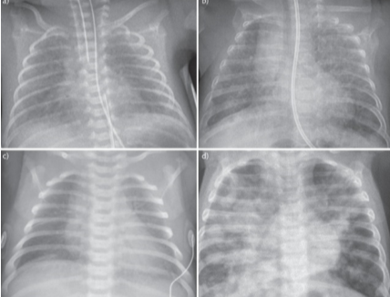
Figure 1. Chest radiograph images (Liu et al., 2021)
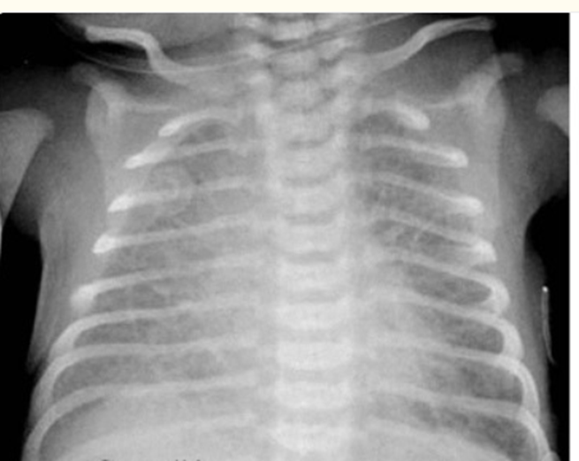
Figure 2: Transient tachypnea of the newborn is characterized by streaky, pulmonary interstitial markings and fluid in the fissure apparent on chest radiograph (Jain et al., 2020)
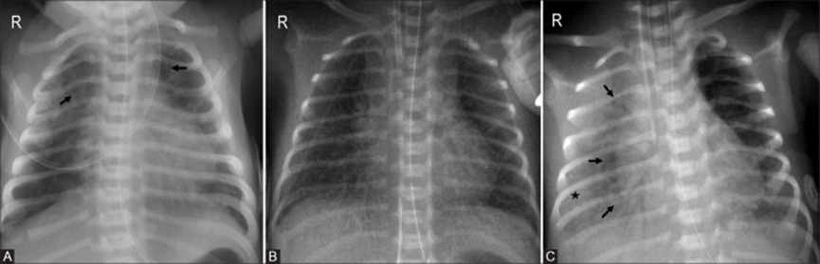
Figure 3: Post surfactant therapy changes. (Jain et al., 2020)
- Pre-treatment: Bilateral diffuse opacities with visible air bronchograms (arrows).
- Post-treatment: Improved lung inflation and resolution of opacities bilaterally.
- Partial response: Marked improvement on the left side, while the right lung retains granular opacities (asterisk) and persistent air bronchograms.
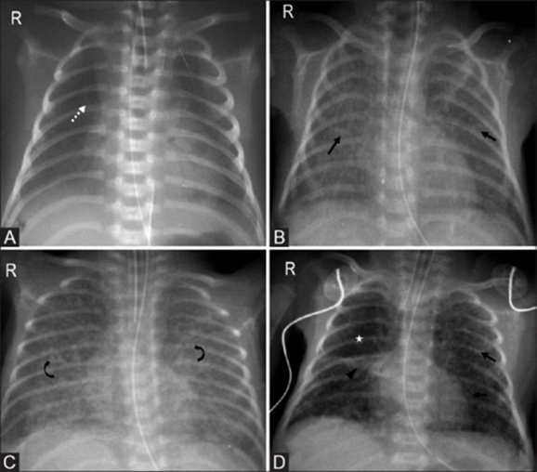
Figure 4. Radiographic transition from RDS to BPD (Jain et al., 2020)
(A) Early phase: Fine granular opacities indicative of RDS (dotted arrow).
(B) Day 7: Progressive bilateral opacities (arrows).
(C) Day 10: Markings become coarser with a honeycomb pattern (curved arrows).
(D) By day 30: Coarse interstitial changes, segmental atelectasis (arrowhead), and signs of hyperinflation (asterisk) consistent with BPD.
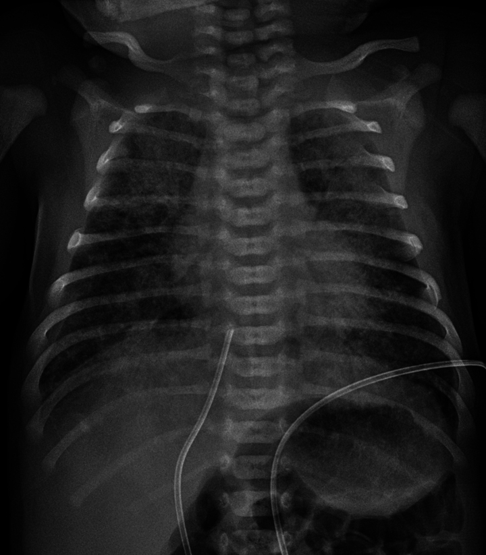
Figure 5. Chest radiography of a full-term infant with meconium aspiration (Dini et al., 2024)
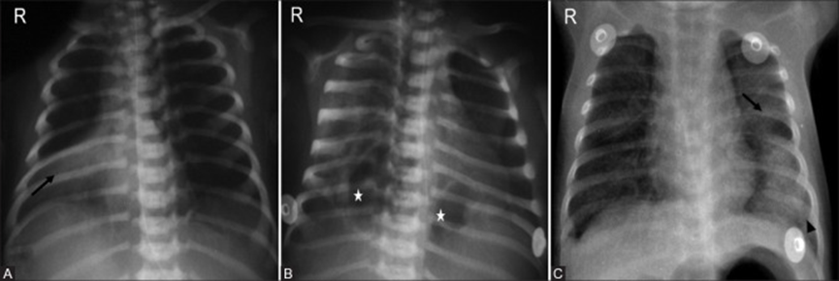
Figure 6: Neonatal pneumonia. (Jain et al., 2020)

